Travel Mart guide

Hotel Vendor

MONTH/YEAR For Internal Distribution Only
Contents
Introduction 2
How to Log In 3
How to change your password 4
Confirm Manifest 5
View data by Date 6
Search 7

Introduction

Last updated: July, 2014
Created by: Chiara van der Kwast
Travel Mart is a web based system created and managed by the Shipboard HR Strategy and Services of Royal Caribbean Cruises Ltd. This tool was designed to provide the users with crewmember travel arrangements. This specific section displays general travel arrangements that the Finance Team might need to refer back to when researching reimbursement approvals.

Note: Reserved arrangements that have not yet been booked will not appear in Travel Mart.

For support or issues with the system, contact SHRSS_Support@rccl.com

How to Log In

Step 1: Go to Https://www.rclcrew.com
Step 2: Enter your Username and Password in the appropriate fields.
Step 3: Click on Log In
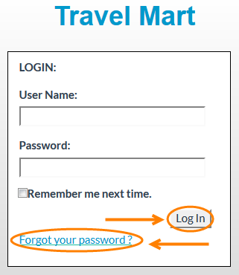
Note: If you are logging in for the first time, enter the username and password provided. Once you have logged in you will be prompted to change your password.
Forgot your password? Click on Forgot your password.
Step 4: Enter your Username and you will receive and email with your password.
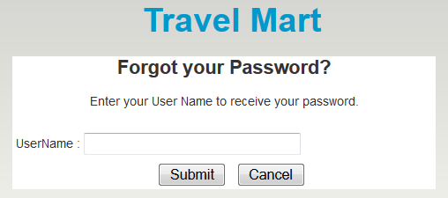

How to change your password

Step 1: At the top right corner of the screen, click on Change Password.
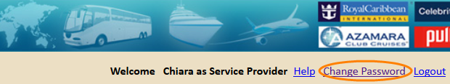
Step 2: In the field Password, enter your current password.
Step 3: In the field New password, enter the new password.
Step 4: Confirm your new password and click on Save.
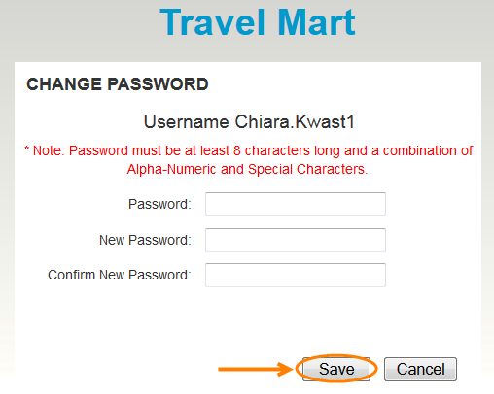

Note: Passwords are case sensitive and must be at least 8 characters long and a combination of Alpha-Numeric and Special Characters.

Confirm Manifest

At the Top of the page you will see the name of the Hotel.
- Click on the icon next to the hotel name.
You will be redirected to the Hotel Contract.
- Click on Export Tentative Manifest if you wish to export the information into an excel spreadsheet
- Select all, multiple or one check box in the Confirm section (top table) and click on Approve. This is only possible when pending with vendor and you wish to approve request. Once it is approved by hotel, the crewmember moves to the Confirmed manifest section.
- Select all, multiple or one check box in the Cancel section and click on Cancel. This is if you wish to cancel request.
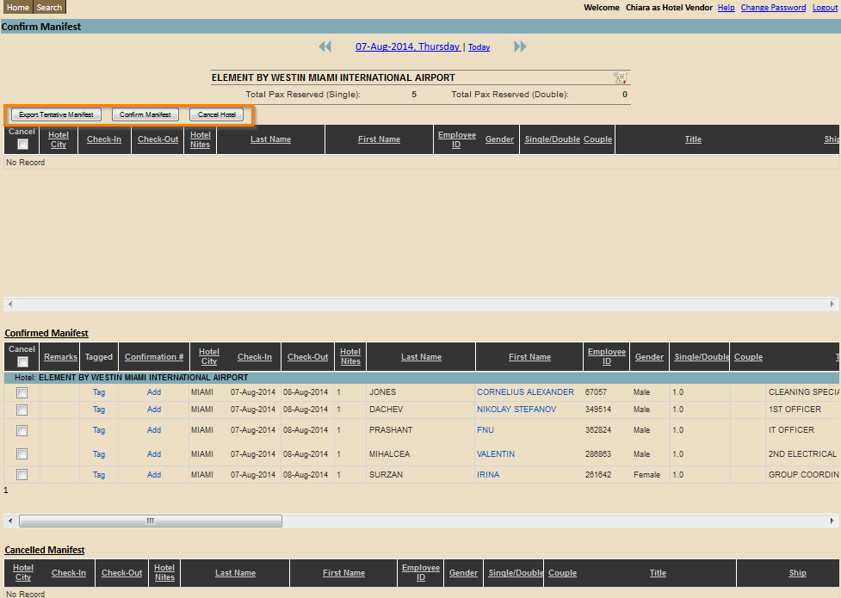

View data by Date
Step 1: Click on the date displayed at the top of the page. A calendar will appear. Or click on the arrows to go back and forth. Select a Date.
A new screen will display information of bookings on that day.
It is possible to filter the information with View data by Date on every page.
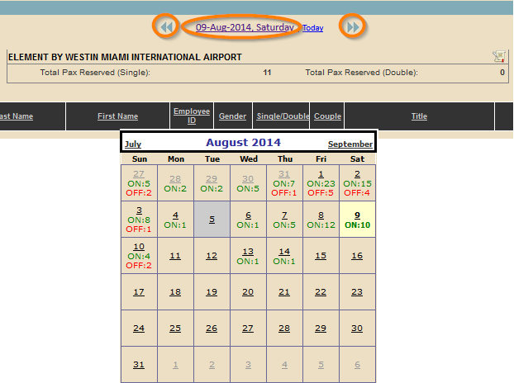
Note: The calendar will also provide the amount of Ons and Offs for the specific days.

Search

Once you have found the correct data you can start reviewing the information visible to you.
On the first page you will be able to view future travel arrangements of the crewmember.
- Scroll back and forth to view all the information provided to you. The information that will be displayed is as follows; E1 Travel number, E1 ID, Name, On/Off Date, Crew Status, Reason Code, Port, Brand, Rank, Air Status, Vehicle Status, Hotel Status, Record Locator, Origin-Destination, Meet & Greet, Service Provider, Hotel vender, and Remarks.

Air, Vehicle, and Hotel status refers to if this service has been scheduled for this specific crew member.
This sign indicates that this service has not been scheduled for this specific crewmember.
This sign indicates that this service has been scheduled for this specific crewmember.
- Select View All on the top left of the page to view past travel arrangements. The travel history will be shown in alphabetical order by ship not by date.
- Click on crewmember name. You will be redirected to a page with more detailed information about the crewmember and travel arrangements.
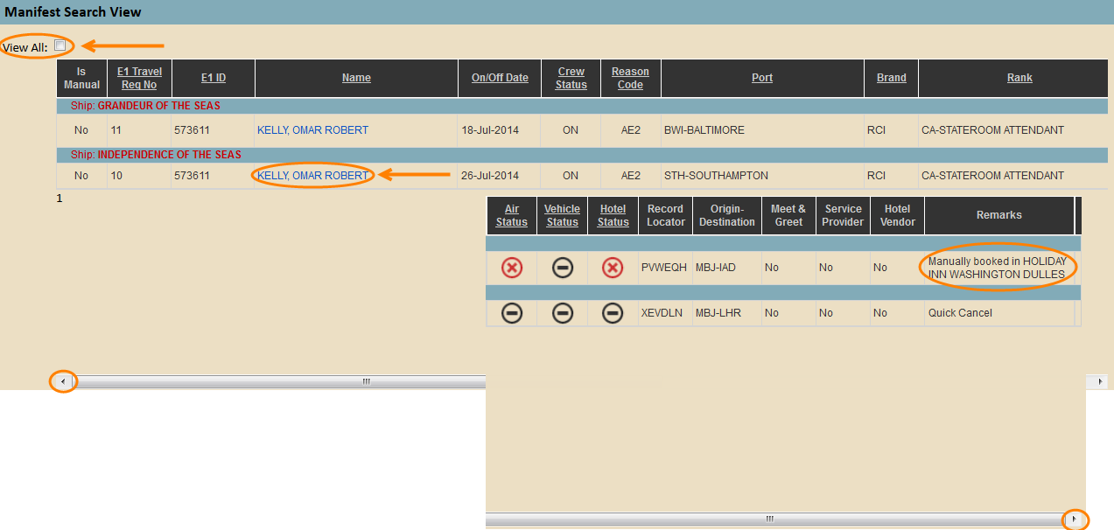
Note: Remarks displayed on the right side of the column are automatically plugged in when changes are made.

You will be able to view: E1 ID, Name, Nationality, Gender, Brand, Ship, Rank, Reason Code, Status, Signing ON Date, Signing OFF Date, and Origin/destination.
All other information is as follows: Air Travel, Vehicle, and Port information.
